

**Chandigarh Group of Colleges,**

**Jhanjeri, Mohali - 140307**

**Department of Computer Science & Engineering**

Mid Term Report

on

**AIML Real Time Face Mask Detection**

Project–I

**BACHELOR OF TECHNOLOGY**

(Computer Science and Engineering)



**SUBMITTED BY:**

Name Roll No.

Prerna Sharma 1816589

Abhinandan Kumar 1816823

Prince Kumar 1816590

22nd February 2021

**Under the Guidance of**

Manuraj Moudgil

Prof. Software Engineering

**Department of Computer Science & Engineering**

**Chandigarh Group of Colleges**

**Jhanjeri, Mohali - 140307**



**Chandigarh Group of Colleges,**

**Jhanjeri, Mohali - 140307**

**Department of Computer Science & Engineering**

**Brief Contents**

Chapter 1: Introduction of AIML face mask detection 5

Chapter 2: System Requirements 2

Chapter 3: Software Requirement Analysis 3

Chapter 4: Software Design 4

Chapter 5: Implementation 5

Chapter 6: References 6



**Chandigarh Group of Colleges,**

**Jhanjeri, Mohali - 140307**

**Department of Computer Science & Engineering**

**Contents in Detail**

**1**

**Introduction**

1.1 Briefing 05

1.1.1 Machine learning and AI technique used 06

1.2 What is computer Vision? 06

1.3 Brief Literature Survey 07

**2**

**System Requirements**

2.1 Software 08

2.1.1 Introduction 08

2.1.2 Advantages of Spyder 08

2.1.3 Steps to install Spyder in windows 09

2.1.4 Steps for installing libraries 11

2.1.4.1 Method 1 12

2.1.4.2 Method 2 13

2.2 Hardware 17

2.2.1 Camera 17

2.2.1.1 How does it work? 17

2.2.1.2 Video Stream 17

* + - 1. Illumination and image quality 18

2.2.1.4 Scene and camera position 18

2.2.1.5 Examples of non – compliance with the requirements 18

2.2.2 Programming interface 22

2.2.3 Notification 22



**Chandigarh Group of Colleges,**

**Jhanjeri, Mohali - 140307**

**Department of Computer Science & Engineering**

**3**

**Software Requirements Analysis**

3.1 Task analysis 23

3.1.1 Overview of the different tasks you perform 23

3.1.2 How to start a project in Spyder? 25

3.2 Form analysis 26

3.2.1 Writing your first project script in your project 26

3.2.2 Spyder IDE features 28

3.2.3 How to run python code in the Spyder IDE 30

3.2.4 How to add a module/packages to Spyder IDE 32

3.2.5 How to check your history log in Spyder 32

**4**

**Software Design**

4.1 Introduction 33

4.2 Two phase COVID – 19 face mask detector 33

4.2.1 Training 34

4.2.2 Deployment 34

4.3 Our COVID – 19 face mask detection datasets 34

4.4 Facial landmarks 35



**Chandigarh Group of Colleges,**

**Jhanjeri, Mohali - 140307**

**Department of Computer Science & Engineering**

**5**

**Implementation**

5.1 Import load model from keras in tensorflow 39

5.2 Implementing face mask detector training script with keras and tensorflow 39

5.3 MobileNetV2 40

5.4 OpenCV2 40

5.5 NumPy 41

5.6 Cascade Classifier 42

5.7 Resize image and classfier.detectMultiScale 43

5.8 Explanations of program 44

5.9 Output of model 45

**6**

**References** 47



**Chandigarh Group of Colleges,**

**Jhanjeri, Mohali - 140307**

**Department of Computer Science & Engineering**

**Chapter 1: Introduction**

**Briefing**

As we know that the COVID-19 pandemic has had a lasting impact in many countries worldwide since December 2019. It was originated in Wuhan, China. The World Health Organization (WHO) as on March 11, 2020, declared it as a deadly disease which gradually gained its roots across the globe and severely affected 114 countries include the country in which we live ie. India a lot. Every medical professional, healthcare organizations, medical practitioners and researchers are in search for a proper vaccines and medicines to overcome this deadly disease, however no breakthrough has been reported till date.

The virus spreads through air channel when an infected person sneezes or communicate with the other person, the water droplets from their nose or mouth disseminate through the air and affect other peoples.

Face Mask detection has become a trending application due to the Covid-19 pandemic, which demands a person to wear face masks, keep social distancing, and use hand sanitizers to wash their hands.

While other problems of social distancing and sanitization have been addressed until now, the issue of face mask detection has not yet been adequately addressed.

Wearing a mask during this pandemic is a critical preventive measure and is most vital step in times when social distancing is hard to maintain. Wearing a mask is essential, particularly for those people who are at a greater risk of severe illness from COVID-19 diseases.

It is found that the spread of COVID-19 is mainly among people who are in immediate contact with one another (nearly about 6 feet), it can be spread by people who do not have symptoms and are unaware of the fact that they are infected.

So Centres for Disease Control and Prevention (CDC)1 recommended all people 2 years of age and older to wear a mask in public areas especially when other social distancing measures are difficult to maintain.

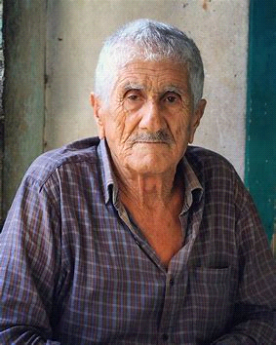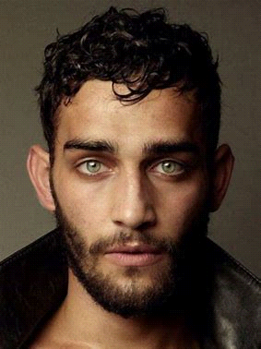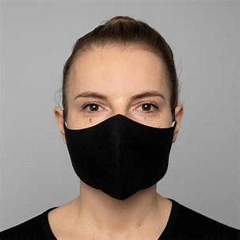



**Chandigarh Group of Colleges,**

**Jhanjeri, Mohali - 140307**

**Department of Computer Science & Engineering**

The world has been fighting this pandemic in great spirit, with the unlocking faces in motion. This is the time to be more proactive than ever. Governments all around the world have recognized the power of Artificial Intelligence and Machine Learning in order to battle the virus. Since 'Social Distancing' and 'Wearing a mask' are the two only ways to avoid the infection till vaccinations become accessible to all of us.

This project is basically based on the same technology of Machine Learning and Artificial Intelligence and it will help in detecting whether a person is wearing a mask or not.The Machine Learning techniques which we are using in this project are as:

* Image Analysis,
* Face Detection
* Computer Vision
* OpenCV

**What is a Computer Vision?**

What exactly is 'Computer Vision', computer vison by definition is an interdisciplinary scientific field developed to make computers acquire high-level understanding from digital images. This fields deals up with how computers can actually be understand or can take information from any picture or real time videos.

From perspective of engineering, we are automating those tasks which are being done by the humans and just based on the current base of scenarios we can use this field to make many more applications too.

For e,g., to monitor social distancing via a " Social Distancing violation Detection" system where you can use a computer vision system in public places to monitor the crowd and the camera will capture images in real time and depending upon the distance each object in the frame is classified as distanced or not distanced. the basic idea here is to avoid crowd gatherings of people in group of 6 or more.

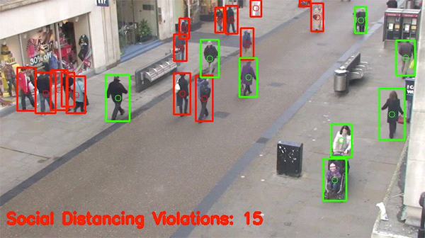



**Chandigarh Group of Colleges,**

**Jhanjeri, Mohali - 140307**

**Department of Computer Science & Engineering**

**Brief Literature Survey**

In the year of 2020 which will be so called as 'COVID19 pandemic' for sure in the future we all get to know that mask played a very important role in our life. At present, in the world the cases of COVID19 have increasing day by day, not even day by day but by minute by minute which is adversely affecting our life as well. Due to this various other types of diseases and viruses are also raising veery rapidly which are causing a lot of serious problems through which many people are suffering.

The most common reason for this infection of person from person is due to some social contacts or due to some aerial infection or one can say physical contacts. So, to safeguard ourself from this diseases and viruses we should wear mask on our face to cover our nose and mouths as well we should keep in pour mind about the social distancing norms.

Still there are some people who are not taking it seriously and are not wearing masks due to which infection is spreading very rapidly. Even, we can analyse the crowds and differentiate the peoples in the crowd who are not wearing mask or the ones who think about their health and wear mask.

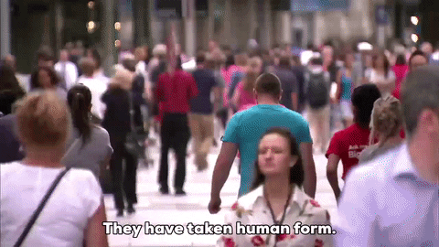

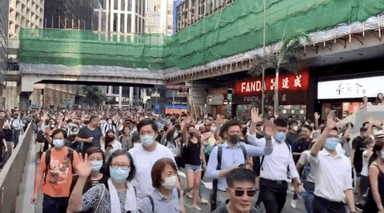



**Chandigarh Group of Colleges,**

**Jhanjeri, Mohali - 140307**

**Department of Computer Science & Engineering**

**Chapter 2: System Requirements**

**Software**

As we know there are many open-source software are availabe for making a perfect model some of the open-source software is pycharm, atom, spyder, sublime, jupyter. In this project we were using Spyder from Anaconda for building this model. You can also use jupter or any other software as according to your comfort. But we personally recommended uses Spyder for writing code and implementation. There have lots of advantages why you choose this software. Few of them are given below.

* **Advantages of Spyder**
* It is a cross – platforms and open – source IDE for python. It is available for windows linux and MAC OS
* It analyzes code to provide automatic code completion, horizontal/vertical splitting, and a go-to-definition.
* It is specifically designed for data scientists; ​hence, it integrates well with data science libraries like NumPy, pandas, tensorflow, opencv, Scipy, and so on.
* It allows you to run and create the multiple IPython console you have no boundation to work on the particular or only on the current console. You are free to work and run code or check debugging in any console that’s the more interesting features why we choose Spyder.
* It includes a powerful integrated debugger which is very beneficial for analysing code in real time what is the error in particular section of program.
* It contains an integrated documentation browser which helps you study or read any time anywhere like online help, are great for beginners.
* It is a light – weight IDE
* Spyder has all the benefits of a comprehensive development tool with the competences of a scientific package. Programmers can extend Spyder by installing other plugins



**Chandigarh Group of Colleges,**

**Jhanjeri, Mohali - 140307**

**Department of Computer Science & Engineering**

* **Steps to install Spyder in windows:**
* Click to the windows

* 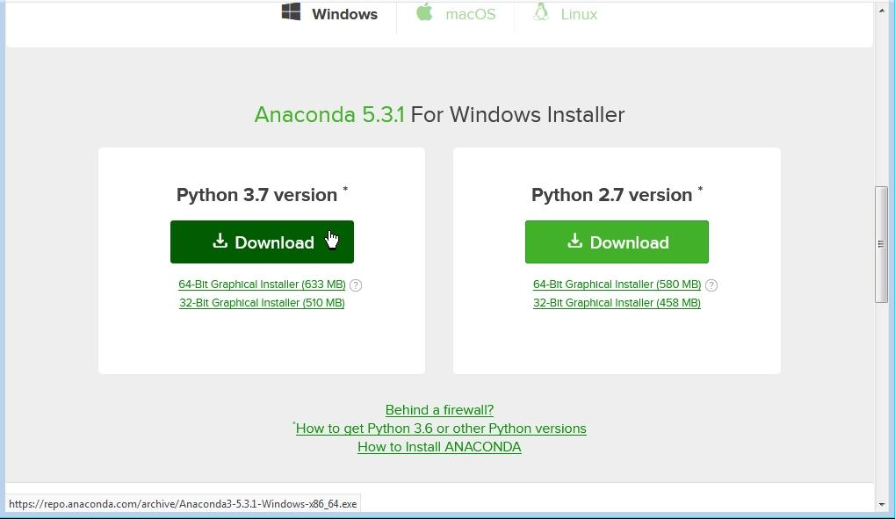Click to the download
* Click to the next



**Chandigarh Group of Colleges,**

**Jhanjeri, Mohali - 140307**

**Department of Computer Science & Engineering**

* 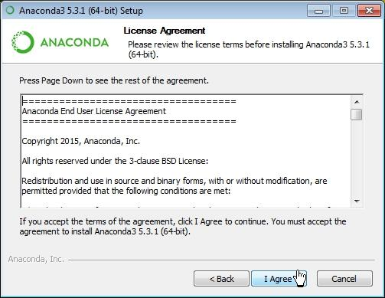Click to the agree
* Click to install
* Skip it



**Chandigarh Group of Colleges,**

**Jhanjeri, Mohali - 140307**

**Department of Computer Science & Engineering**

* 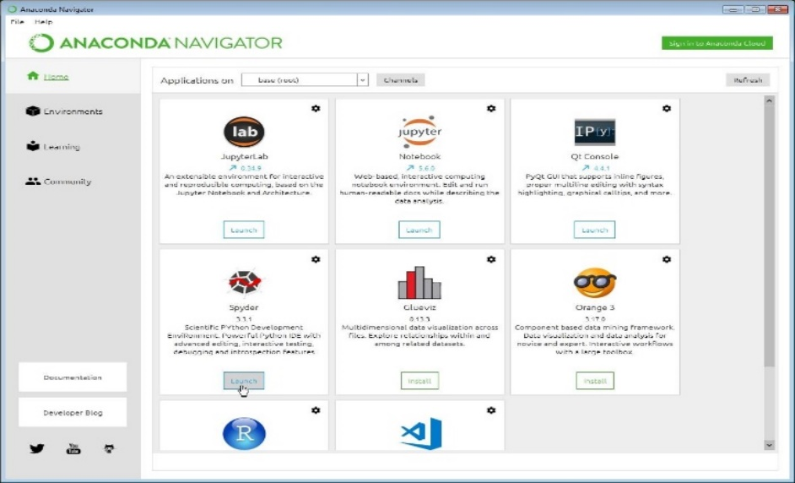If you like to use Spyder click to launch
* 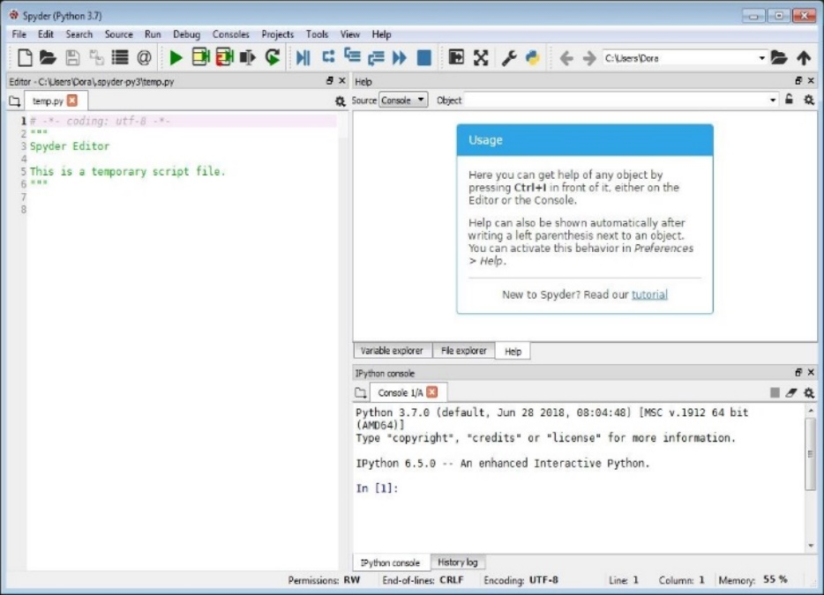Your ide is read for work
* **Steps for installing libraries:**

In Spyder most of the libraries is preinstalled but some of the libraries according to our requirement needed to be installed. For building AIML real face mask detection model libraries we need for:

* 1. Numpy
  2. OpenCV (newest version)
  3. Tensorflow (newest version)
  4. MobileNetV2
  5. h5py (newest version)
* 

**Chandigarh Group of Colleges,**

**Jhanjeri, Mohali - 140307**

**Department of Computer Science & Engineering**

We can install all those libraries in two ways either Anaconda Prompt/terminal or directly from Anaconda environment. We mention both of the method you can go through any of them:

**Method 1:**

* 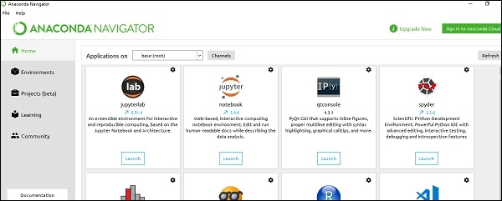Go to the anaconda navigator
* 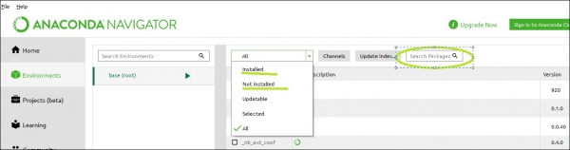Click on the “Environment” tab and from there we can check which libraries are installed or not. After that click on the search bar then type libraries name which one you want to install.
* 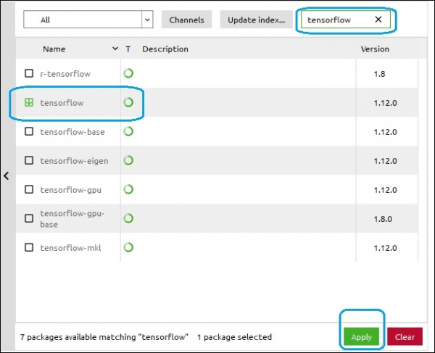It shows is the library installed or not. If not then select the library option you want to install and click the apply button your library is install in your Anaconda environment.



**Chandigarh Group of Colleges,**

**Jhanjeri, Mohali - 140307**

**Department of Computer Science & Engineering**

**Method 2:**

* Open Anaconda prompt or terminal (it also supports pip command)

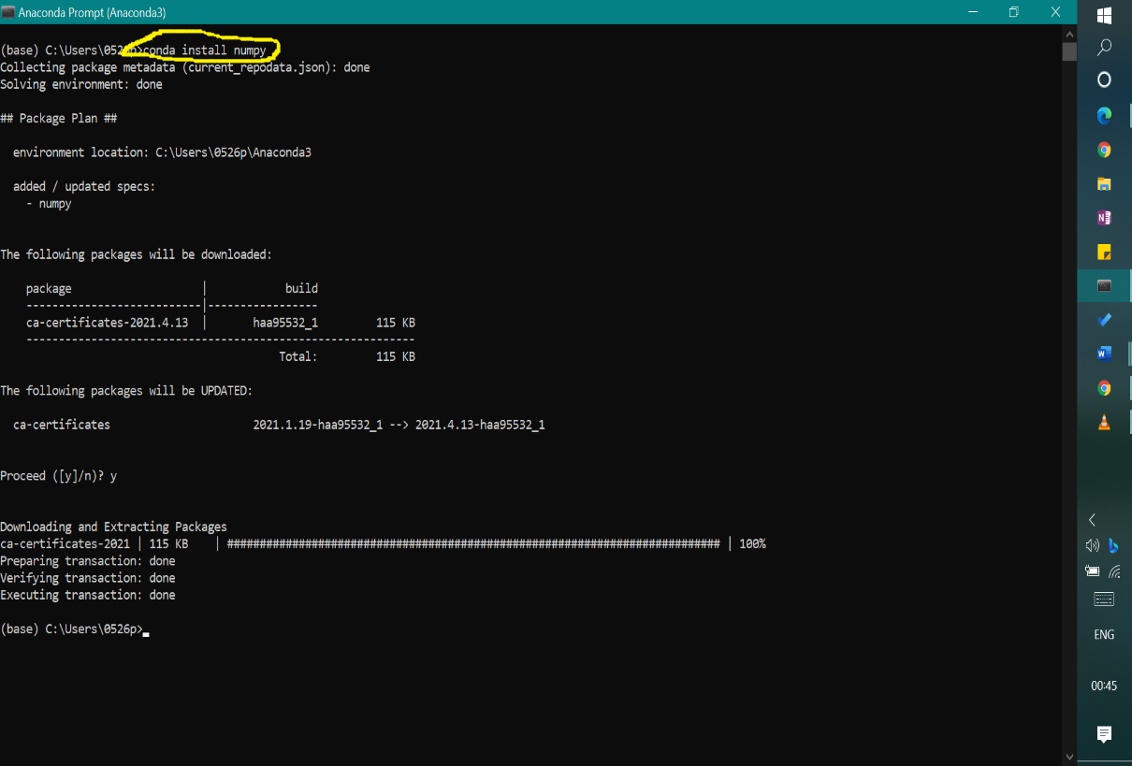conda install numpy

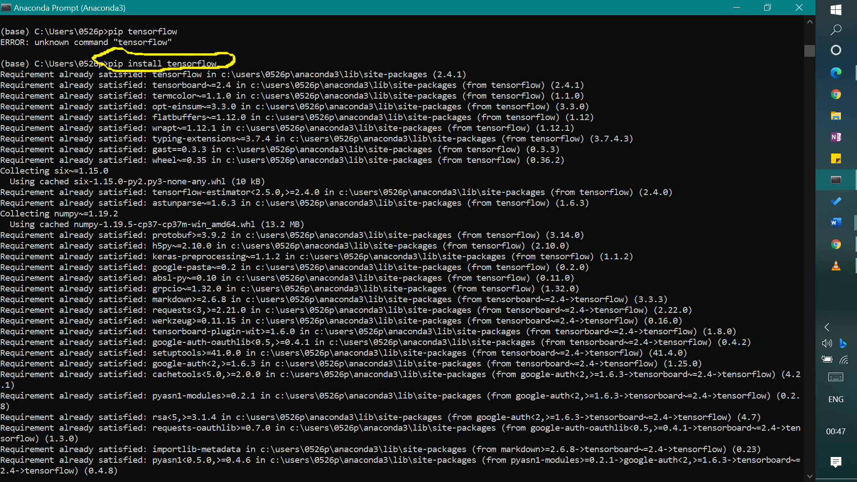pip install tensorflow (it also woks)



**Chandigarh Group of Colleges,**

**Jhanjeri, Mohali - 140307**

**Department of Computer Science & Engineering**

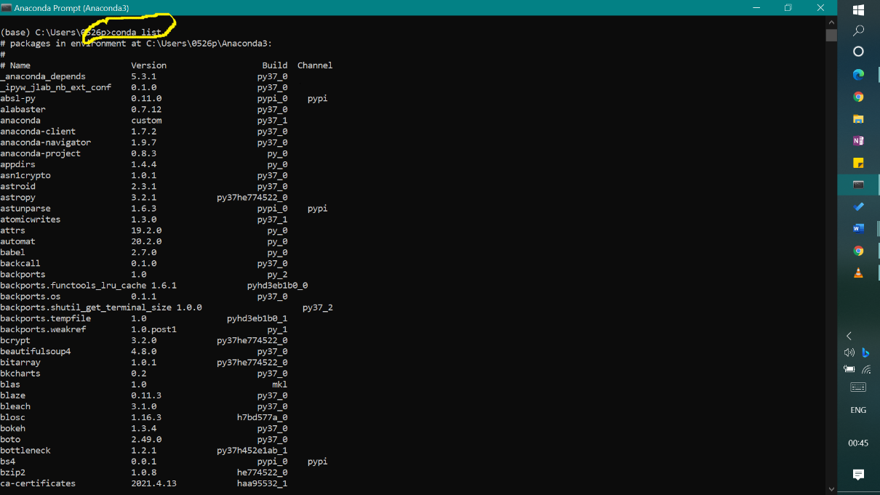conda list

conda pip

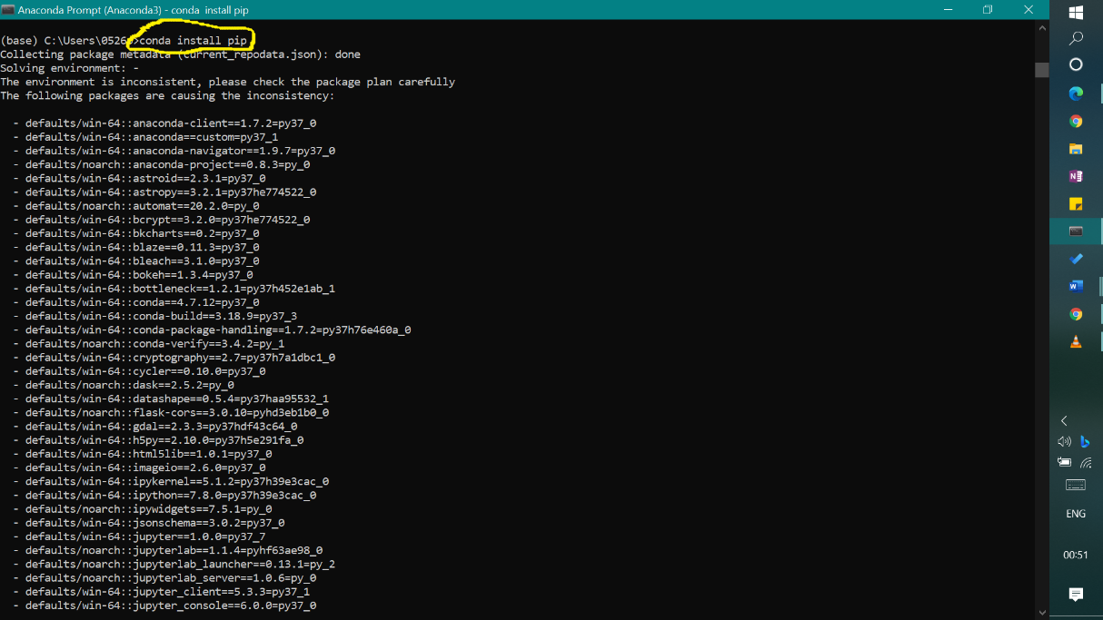

Note: After install pip it ask for confirmation to setup on the environment, extracting and downloading packages



**Chandigarh Group of Colleges,**

**Jhanjeri, Mohali - 140307**

**Department of Computer Science & Engineering**

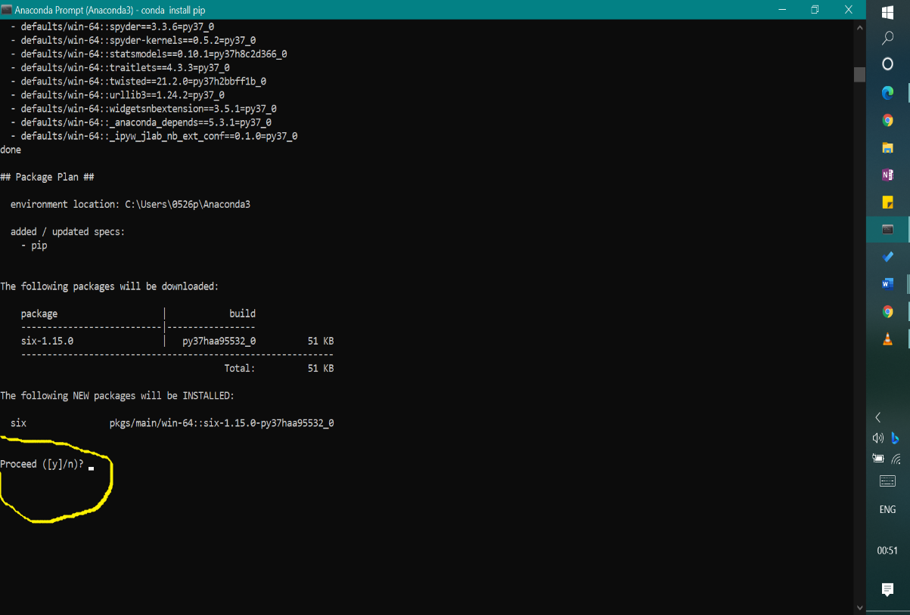

Enter “y” for continue

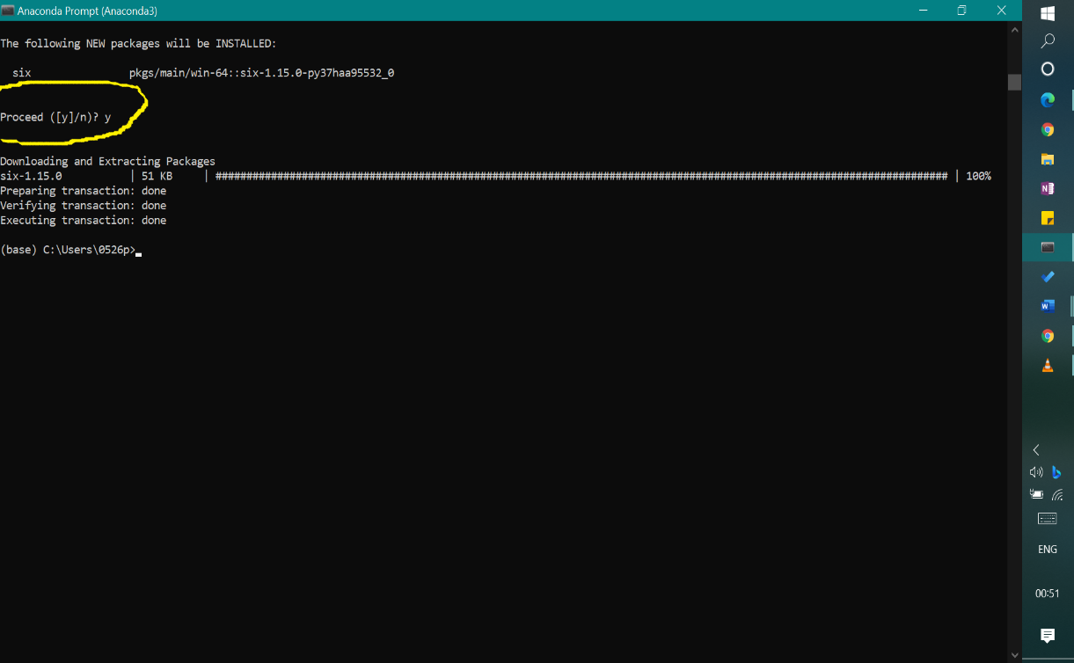



**Chandigarh Group of Colleges,**

**Jhanjeri, Mohali - 140307**

**Department of Computer Science & Engineering**

**Hardware**

* 1. **Camera**

We can use CCTV or IP cameras for real time face mask detection we can also use computer webcam for that purposes but it affects the accuracy level and image quality also depend on face mask detection we discussed about that in below, how image quality affect the real time face mask detection so, we understand better. Face Mask Detection System uses existing IP cameras and CCTV cameras combined with Computer Vision to detect people without masks.

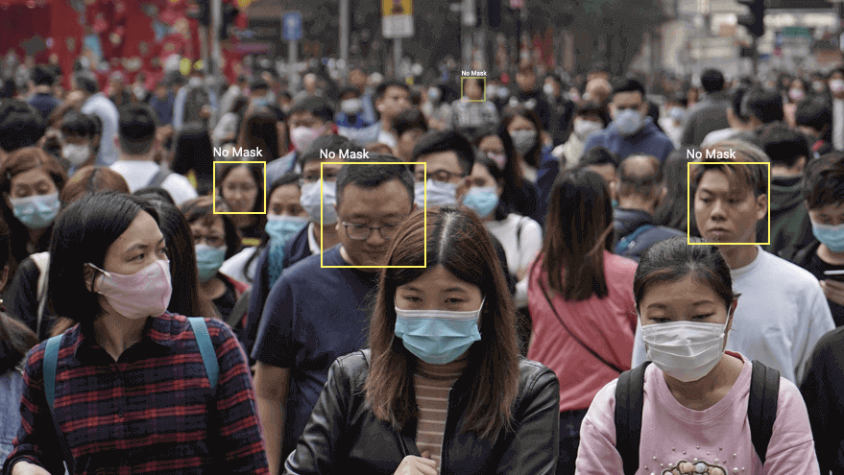

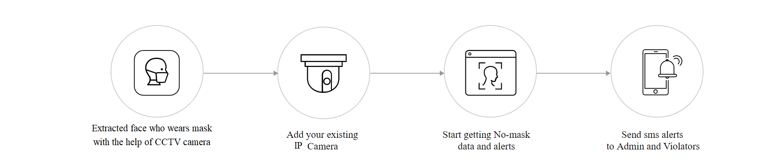 **How does it work?**

* + - **Video Stream**

1. Optimum resolution for the module’s operation: HD or FullHD.
2. Framerate: 10 fps or more.
3. No mirrored (horizontally flipped) stream.



**Chandigarh Group of Colleges,**

**Jhanjeri, Mohali - 140307**

**Department of Computer Science & Engineering**

* + - **Illumination and image quality**

1. Illumination of faces in the frame must be uniform.
2. If the camera is installed opposite a bright source of light (sun behind the entrance door, etc.), it is required to adjust the exposure or brightness in such a way that the face in the frame is light.
3. The image quality must be medium or better. Significant compression artefacts are not acceptable.
4. No blurring of moving people’s faces is allowed.
   * + **Scene and camera position**
5. The faces must be fully seen in the frame.
6. There must be no mirror surfaces giving reflections in the frame (glass, mirrors, etc.).
7. Strong lateral illumination (e.g., sunlight from the window) resulting in the overexposure of one part of the face is not acceptable.
8. The camera may be placed above the face level, directly facing the people to be recognized. In such a case, the camera elevation angle must not exceed 35°. The camera must directly face the people to be recognized.
   * + **Examples of non-compliance with the requirements** 
       - 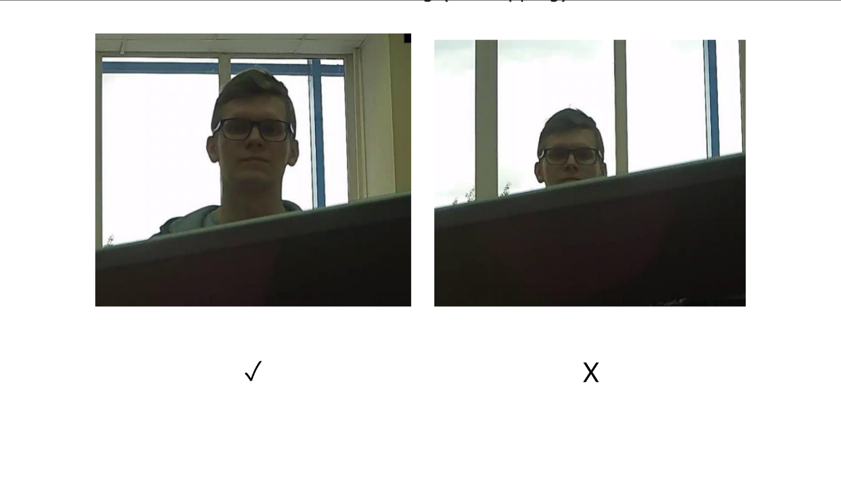Covering (overlapping):



**Chandigarh Group of Colleges,**

**Jhanjeri, Mohali - 140307**

**Department of Computer Science & Engineering**

* + - * 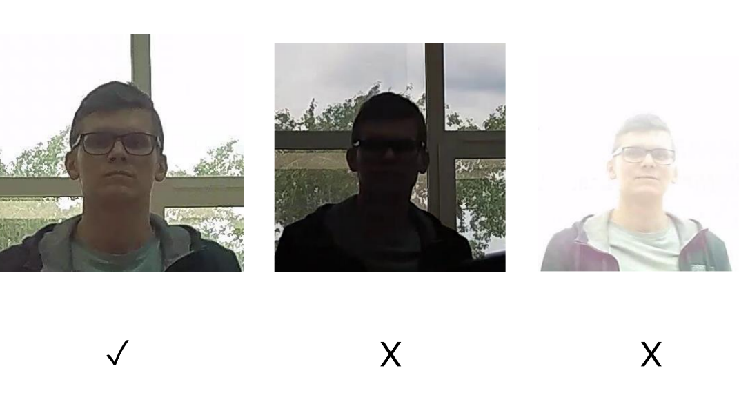Face illumination:
      * 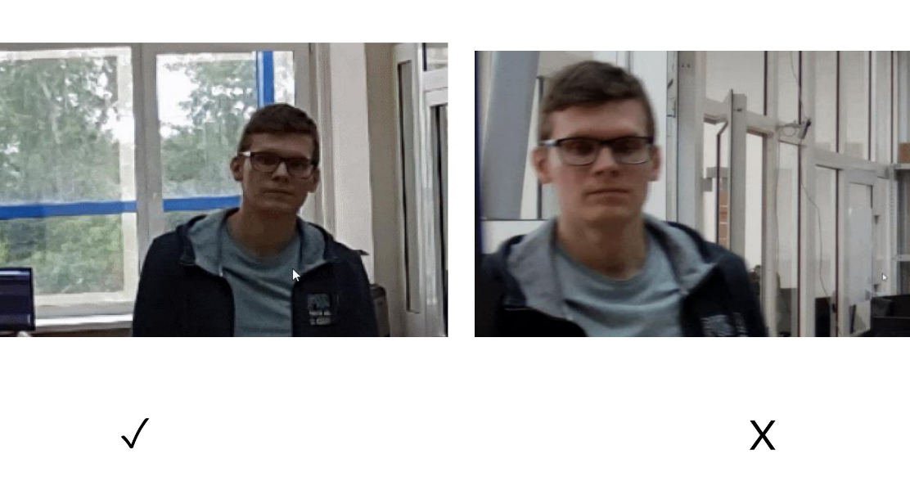Blurring of face in motion:

* + - * Unacceptable distance between pupils:

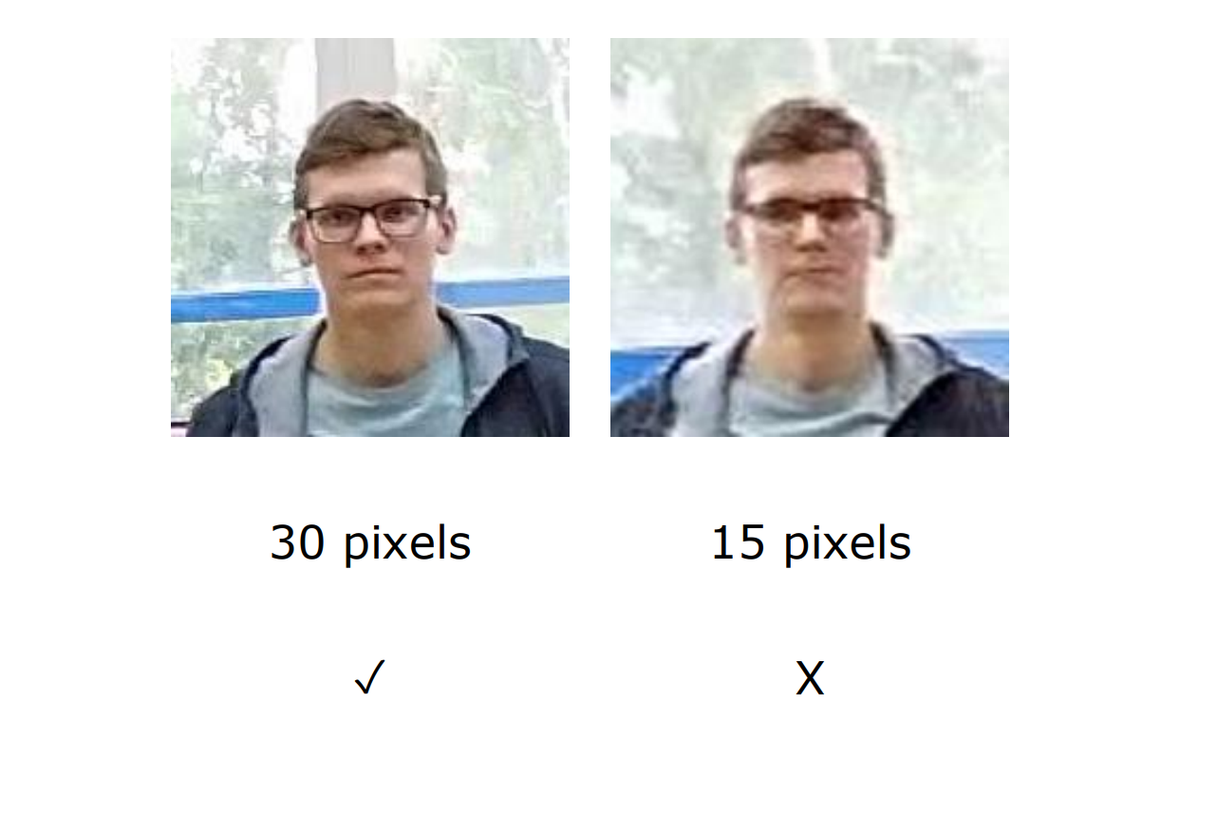



**Chandigarh Group of Colleges,**

**Jhanjeri, Mohali - 140307**

**Department of Computer Science & Engineering**

* + - * 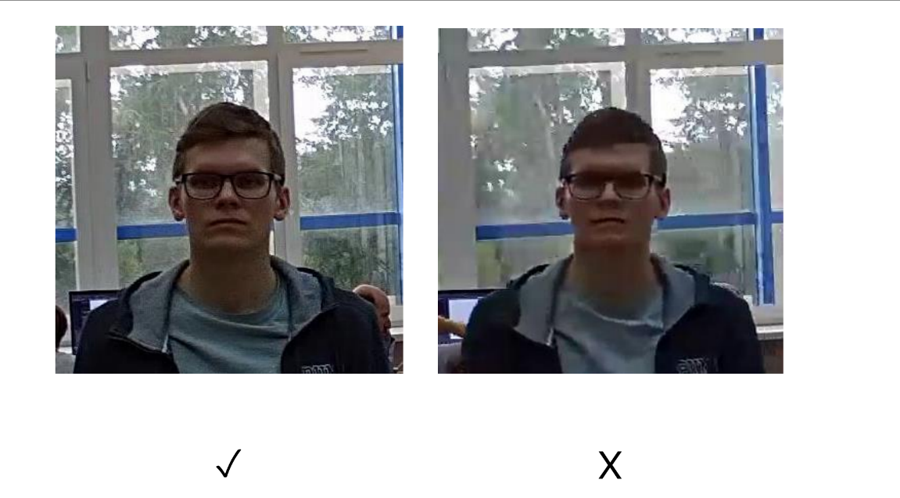Video stream quality:
      * 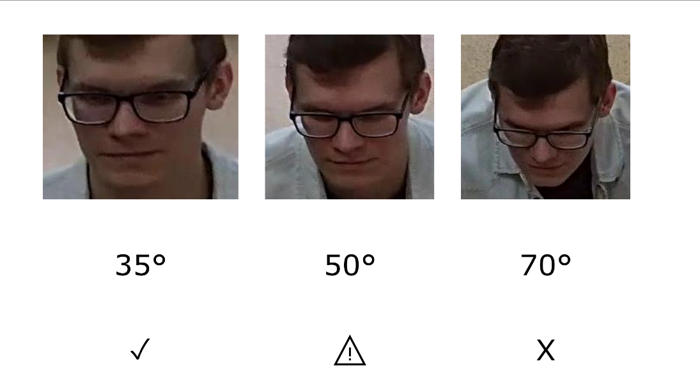Camera tilt:

* + - * Lateral light source:

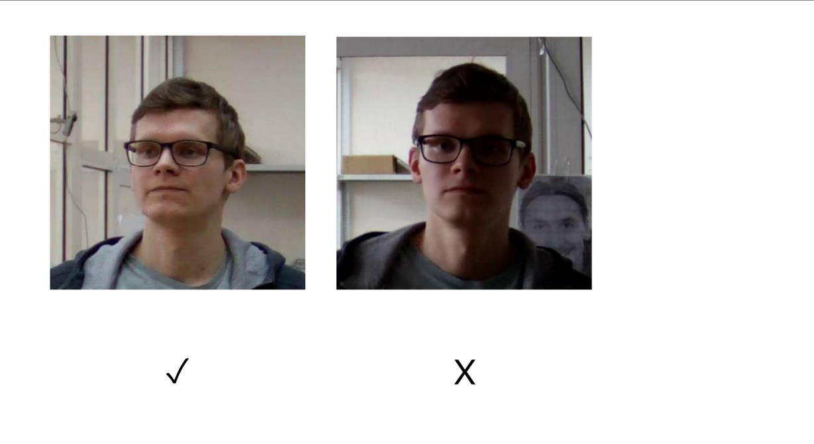



**Chandigarh Group of Colleges,**

**Jhanjeri, Mohali - 140307**

**Department of Computer Science & Engineering**

* + - * 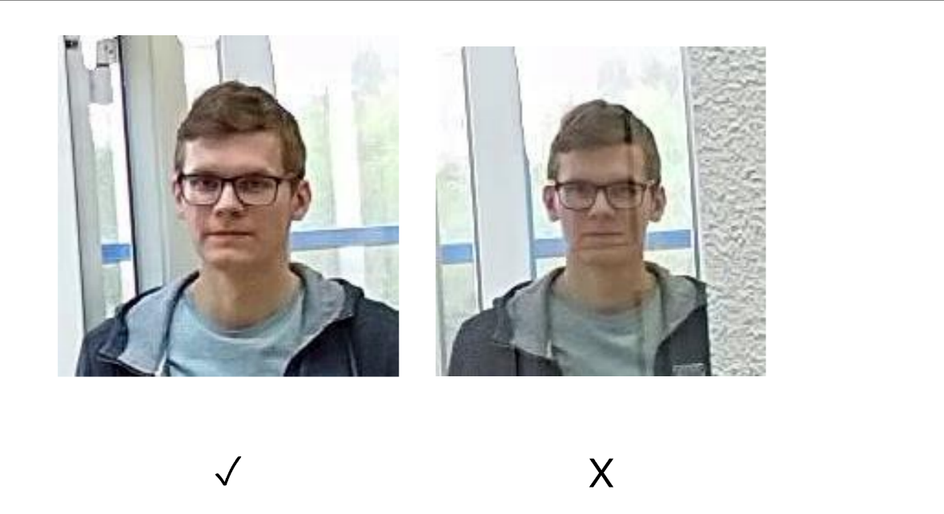Reflecting surfaces:
      * Horizontal turn of camera from face plane:

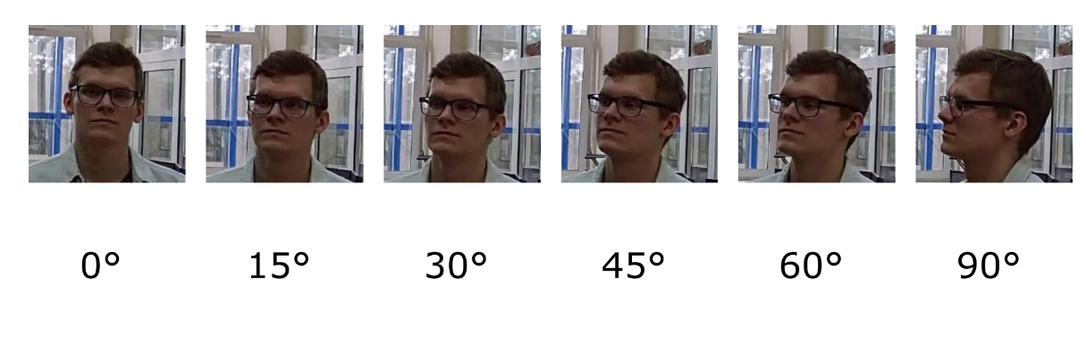

* + - * 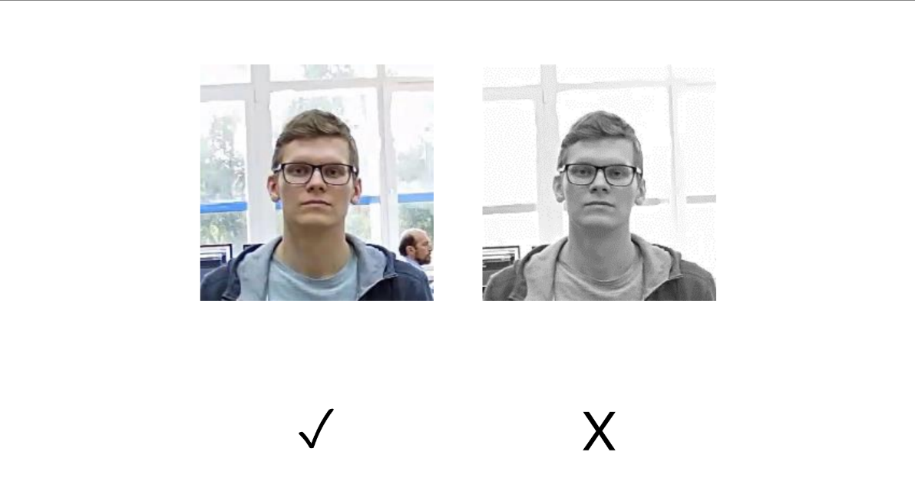Black and white image (night mode):



**Chandigarh Group of Colleges,**

**Jhanjeri, Mohali - 140307**

**Department of Computer Science & Engineering**

1. **Programming interface**

We use Arduino uno or nano with ESP32 CAM for programming and building the model in project based but if we can want to implement the model then we can use Raspberry Pi 3 or 4 and Beaglebone (BeagleBoard) for programming interface BeagleBone Black is a low-cost, community-supported development platform for developers and hobbyists. I like to use BeagleBoard.

1. **Notification interface**

If we want to implement that model in large scale then we use the devices like metal detector for face mask detection just change the features from metal detector to the face mask detector in the main entrances. In the face mask detector, we install the cameras if the camera identifies a user that he / she was not wearing a mask, AI alerts the system and bugger are sounding or led lights are blinking. Stop that person entrances and enforces the person to wearing mask. Until he/she not wear mask he is not eligible to enter.



**Chandigarh Group of Colleges,**

**Jhanjeri, Mohali - 140307**

**Department of Computer Science & Engineering**

**Chapter 3: Software Requirements Analysis**

**Task analysis**

When we installed software, we needed to understand the functionalities and features of that software before working because if we are not familiar with the working tools and environment we are not work probably and not know how to use that proper features and most important where. User must view the software as services provided by it – service as task. Then we summarise the task in the model problem what work you have going to do in the software requirements of model such as libraries, tools, skills required. If you have any dought for your working directory then you can go the Anaconda environment, read the documentation page, there is complete step by step working of different functionalities.

* **Overview of the different tasks you perform**
  + 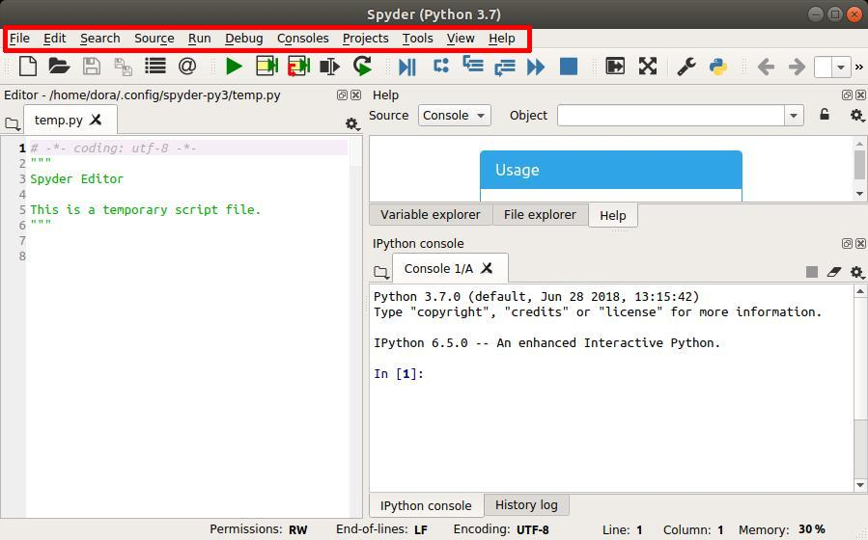  At the top is the main menu:
  + 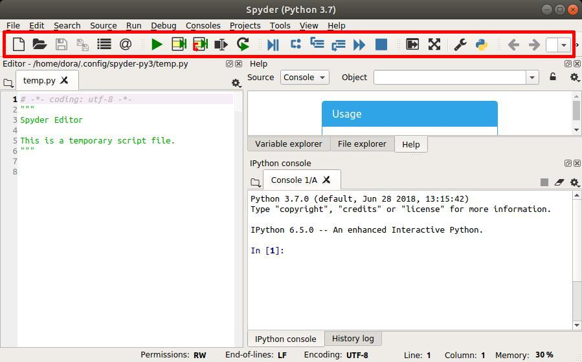Underneath it is a toolbar:



**Chandigarh Group of Colleges,**

**Jhanjeri, Mohali - 140307**

**Department of Computer Science & Engineering**

* + On the right side is an **interactive console** where you can write and run code:

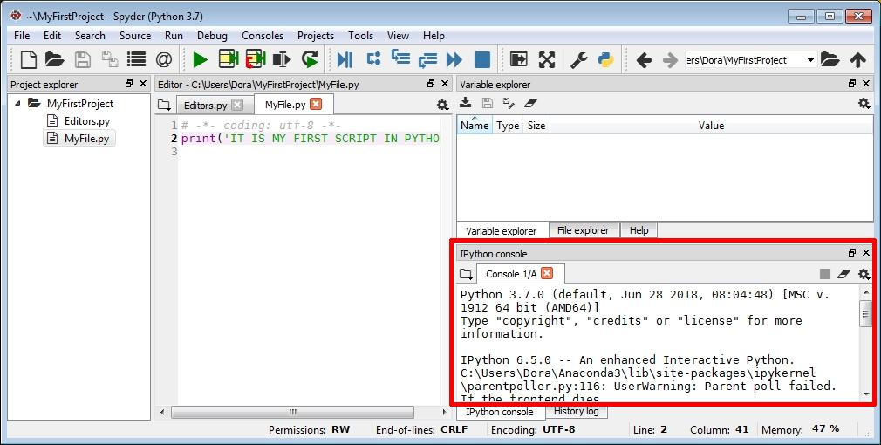

* + 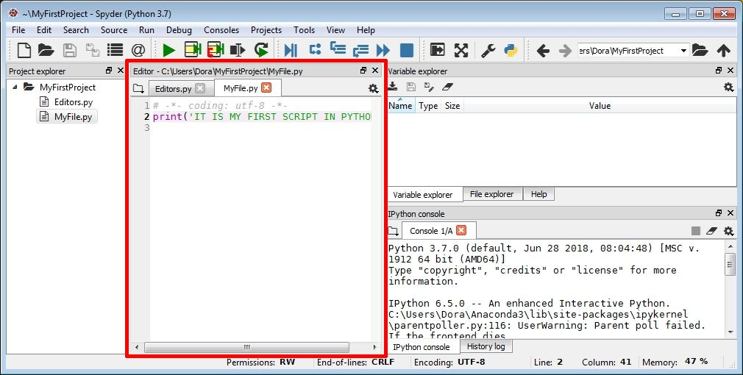On the left is an **editor** where you can write and save Python scripts:



**Chandigarh Group of Colleges,**

**Jhanjeri, Mohali - 140307**

**Department of Computer Science & Engineering**

* + To the left of the editor is the **Project Explorer** pane, which displays all project nodes with their related folders and files:

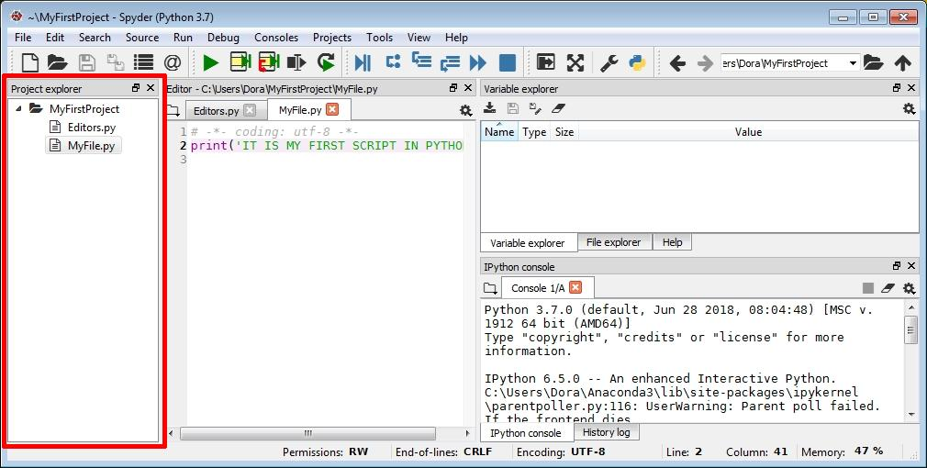

* **How to start a project in Spyder:**
  + In the Spyder IDE, as in other IDEs, we can create a project to organize our files, like images, scripts, and related text files. To create a project, simply select **Projects** › **New Project** from the main menu. The **Create new project** window will display.

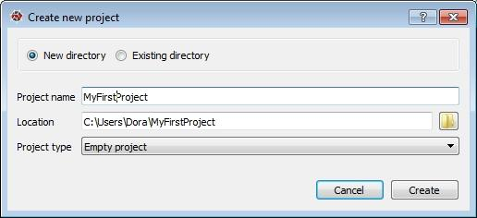

* + Fill in the information for your project, including its name and directory (if the selected directory already exists). When you're done, click the **Create** button.



**Chandigarh Group of Colleges,**

**Jhanjeri, Mohali - 140307**

**Department of Computer Science & Engineering**

* + You'll see the project folder in the *Project explorer* pane.

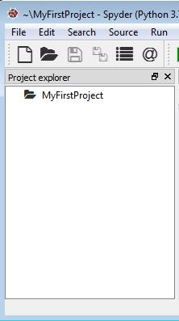

**Form Analysis**

Analysis of different data input and output of the system how it will get the input, process it and giving output.

* **Writing your first project script in your project**
  + Every project contains files: code, pictures, libraries, text files, and more. We'll create a file that allows us to write a Python script. Right-click on your project folder, and choose **New** › **File**.

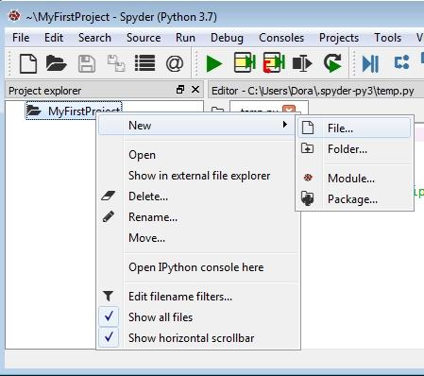



**Chandigarh Group of Colleges,**

**Jhanjeri, Mohali - 140307**

**Department of Computer Science & Engineering**

* + The **New File** dialog displays. Enter the name of your script (ours is MyFile), and click **Save**. Remember to add a **.py** extension at the end of name of the file name to designate it as a Python script.

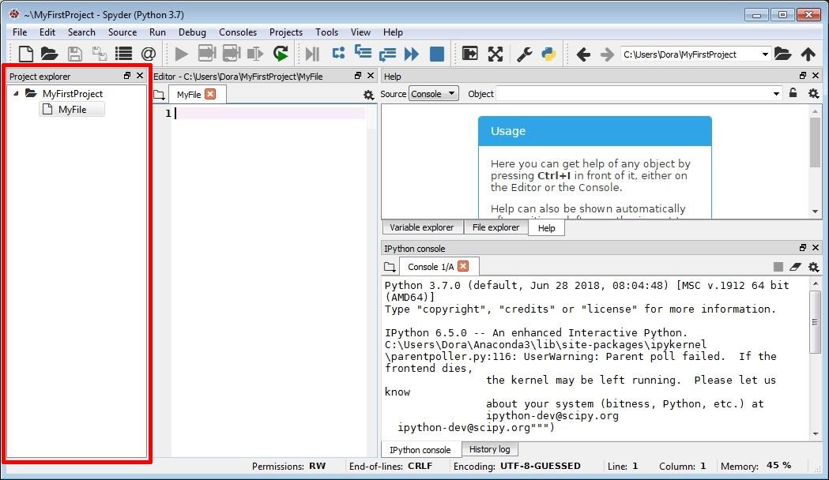

* + The file will also automatically be opened in the Editor pane. Here, we can write Python code, like this:

print(“This is my first script in python”)

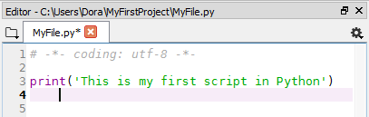

* + You can then save your file by pressing Ctrl+S or choosing **File** › **Save** from the menu.

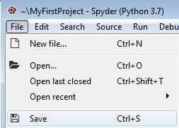



**Chandigarh Group of Colleges,**

**Jhanjeri, Mohali - 140307**

**Department of Computer Science & Engineering**

* **Spyder IDE Features**
  + Comments

One of the available features allows you to quickly add block comments to your code. Click on the line where you'd like to insert a block comment, and then select **Edit** › **Add block comment** from the menu.

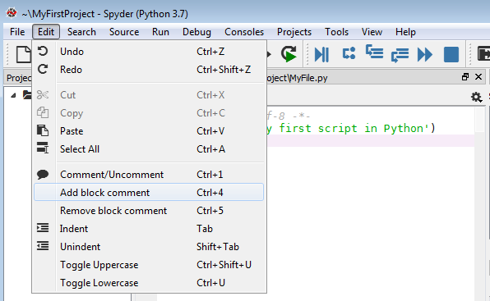

This will insert a block comment like so:

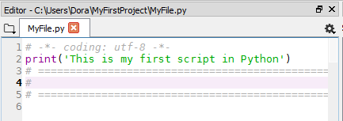

In a similar way, you can remove block comments using the Edit menu — just click inside the comment block, and choose **Remove block comment**.



**Chandigarh Group of Colleges,**

**Jhanjeri, Mohali - 140307**

**Department of Computer Science & Engineering**

* + Syntax Highlighting

If you look at the code in your editor, you'll see many different colors: strings are in green, brackets in bright green, the names of functions are violet. This is known as syntax highlighting—a feature that most text editors have to make it easier for you to find relevant parts of your code.

To begin, go to **Tools** › **Preferences**.

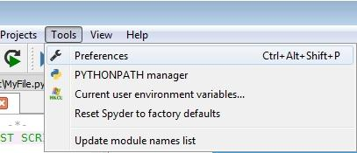

The **Preferences** window displays. Choose **Syntax coloring** on the left, and

click the **Edit selected** button on the right

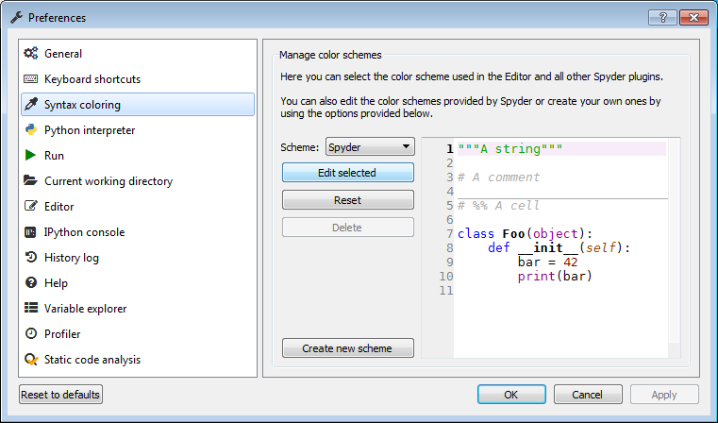

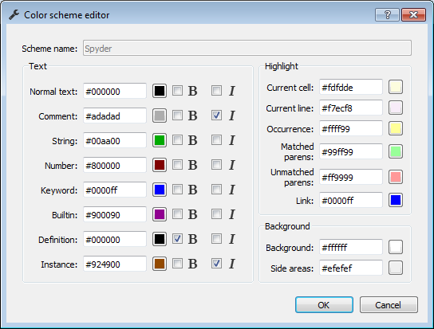You'll see the **Color scheme** editor, which lets you change the colors for different parts of your code. After making changes, click the **OK** button.



**Chandigarh Group of Colleges,**

**Jhanjeri, Mohali - 140307**

**Department of Computer Science & Engineering**

* + Syntax warnings and auto – completion

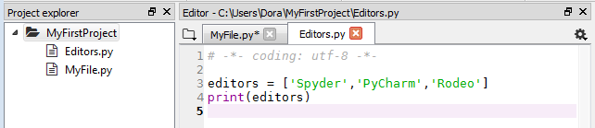

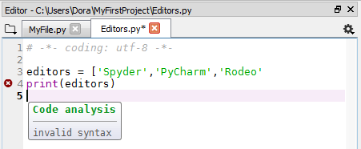

* **How to run python code in the Spyder IDE**
  + We can run project files using the green **Run** button from the toolbar. Alternatively, you can select **Run** › **Run** from the main menu or use the shortcut key (F5).

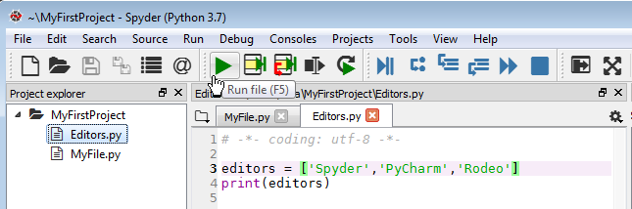

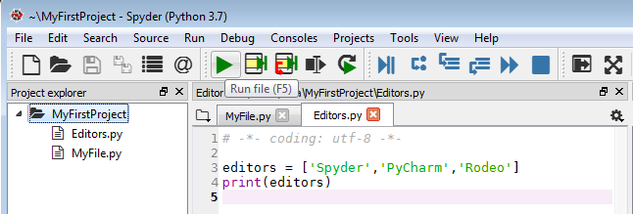



**Chandigarh Group of Colleges,**

**Jhanjeri, Mohali - 140307**

**Department of Computer Science & Engineering**

* + You'll see the result of running your currently active file in the Console pane:

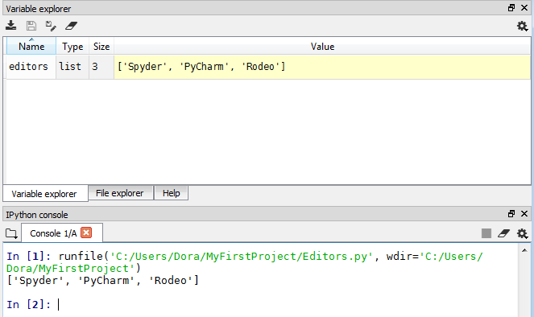

* + sometimes we make non-syntactic errors when coding. In this situation, after running your code, you'll see the error summary in the **Console** pane.

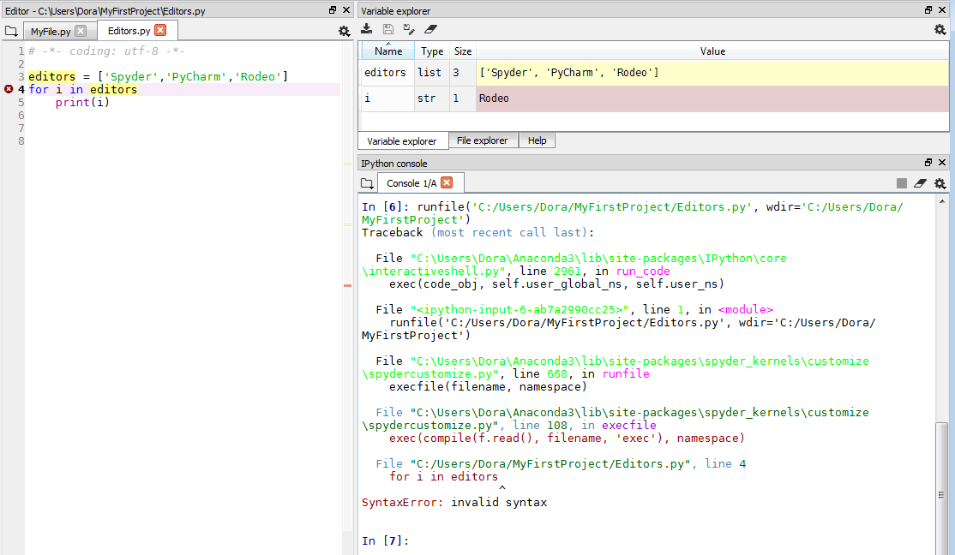

As in most IDEs, you can also debug your program. There's a group of debug buttons that allow you to run an application and debug it step by step to find errors.



**Chandigarh Group of Colleges,**

**Jhanjeri, Mohali - 140307**

**Department of Computer Science & Engineering**

* **How to add a module / packages to Spyder IDE**

!pip install logbook 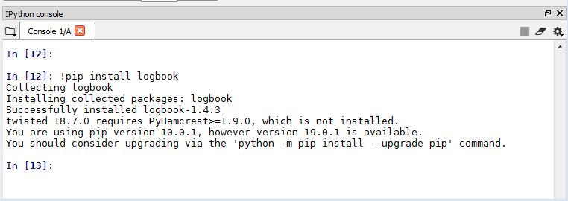

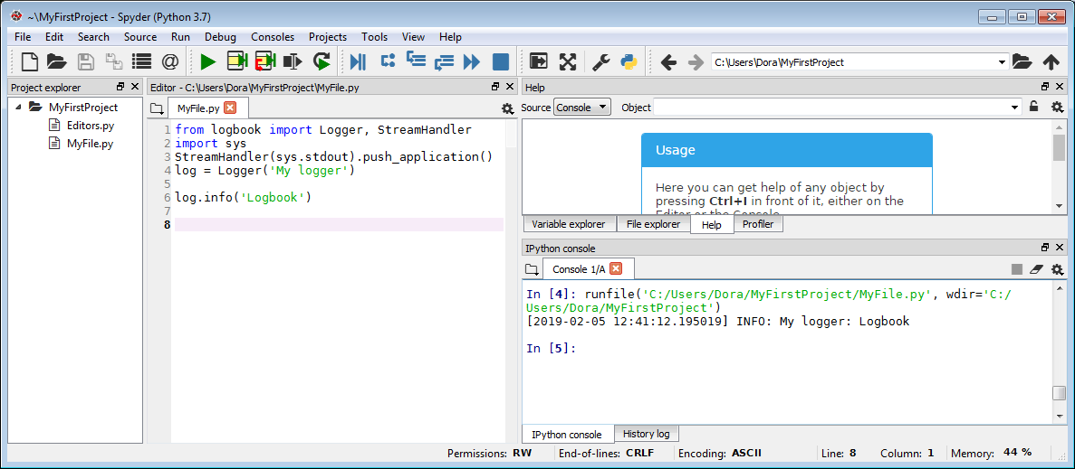

* **How to check your history log in Spyder**

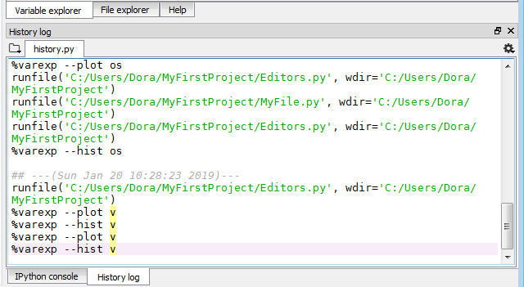

Note: Or simply press up / down arrow in the keyboard



**Chandigarh Group of Colleges,**

**Jhanjeri, Mohali - 140307**

**Department of Computer Science & Engineering**

**Chapter 4: Software Design**

* **Introduction**

In this model, we’ll discuss our two-phase COVID-19 face mask detector, detailing how our computer vision/deep learning pipeline will be implemented.

From there, we’ll review the dataset we’ll be using to train our custom face mask detector.I’ll then show you how to implement a Python script to train a face mask detector on our dataset using Keras and TensorFlow.We’ll use this Python script to train a face mask detector and review the results.

Given the trained COVID-19 face mask detector, we’ll proceed to implement two more additional Python scripts used to:

1. Detect COVID-19 face masks in *images*
2. Detect face masks in *real-time video streams*

We’ll wrap up the post by looking at the results of applying our face mask detector.

* **Two – phase COVID – 19 face mask detectors**

Phases and individual steps for building a COVID-19 face mask detector with computer vision and deep learning using Python, OpenCV, and TensorFlow/Keras.

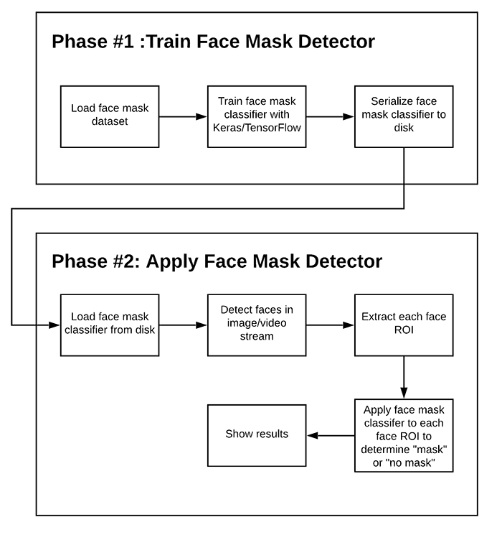



**Chandigarh Group of Colleges,**

**Jhanjeri, Mohali - 140307**

**Department of Computer Science & Engineering**

In order to train a custom face mask detector, we need to break our project into two distinct phases, each with its own respective sub-steps (as shown by **Figure 1** above):

1. **Training:** Here we’ll focus on loading our face mask detection dataset from disk, training a model (using Keras/TensorFlow) on this dataset, and then serializing the face mask detector to disk
2. **Deployment:** Once the face mask detector is trained, we can then move on to loading the mask detector, performing face detection, and then classifying each face as

With mask

 or

without mask

We’ll discuss each of these phases and associated subsets in detail in this model, but before discussion, let’s take a look at the dataset we’ll be using to train our COVID-19 face mask detector.

* **Our COVID – 19 face mask detection datasets**

A face mask detection dataset consists of “with mask” and “without mask” images. We will use the dataset to build a COVID-19 face mask detector with computer vision and deep learning using Python, OpenCV, and TensorFlow/Keras.

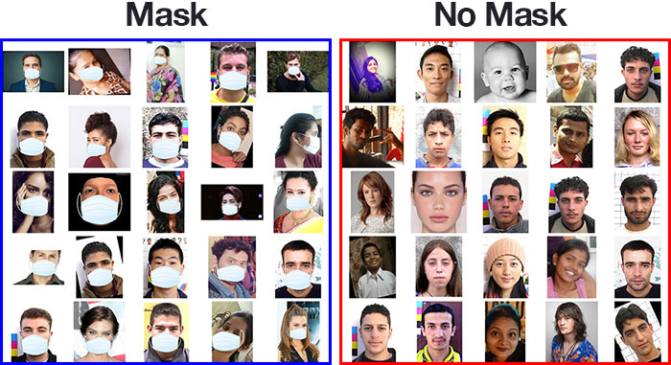



**Chandigarh Group of Colleges,**

**Jhanjeri, Mohali - 140307**

**Department of Computer Science & Engineering**

\

* **Facial landmarks**

Facial landmarks allow us to automatically infer the location of facial structures, including:

* Eyes
* Eyebrows
* Nose
* Mouth
* Jawline
  + To use facial landmarks to build a dataset of faces wearing face masks, we need to first start with an image of a person not wearing a face mask:

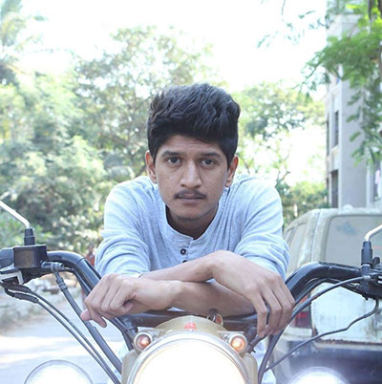



**Chandigarh Group of Colleges,**

**Jhanjeri, Mohali - 140307**

**Department of Computer Science & Engineering**

* + From there, we apply face detection to compute the bounding box location of the face in the image.The next step is to apply face detection. Here we’ve used a deep learning method to perform face detection with OpenCV. Once we know where in the image the face is, we can extract the face Region of Interest (ROI):

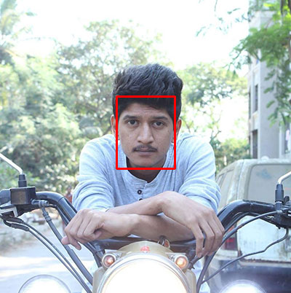

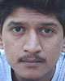



**Chandigarh Group of Colleges,**

**Jhanjeri, Mohali - 140307**

**Department of Computer Science & Engineering**

* + The next step is to extract the face ROI with OpenCV and NumPy slicing. And from there, we apply facial landmarks, allowing us to localize the eyes, nose, mouth, etc. Then, we [detect facial landmarks](https://www.pyimagesearch.com/2017/04/03/facial-landmarks-dlib-opencv-python/) using dlib so that we know where to place a mask on the face.

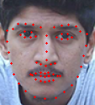

* + Next, we need an image of a mask (with a transparent background) such as the one below. This face mask will be overlaid on the original face ROI automatically since we know the face landmark locations

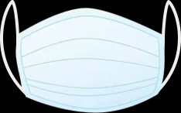.



**Chandigarh Group of Colleges,**

**Jhanjeri, Mohali - 140307**

**Department of Computer Science & Engineering**

* + This mask will be automatically applied to the face by using the facial landmarks (namely the points along the chin and nose) to compute where the mask will be placed. The face mask is placed on the person’s face in the original frame. It is difficult to tell at a glance that the COVID-19 mask has been applied with computer vision by way of OpenCV and dlib face landmarks. The mask is then resized and rotated, placing it on the face.

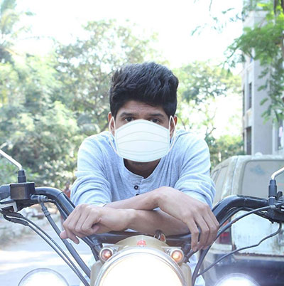

* + We can then repeat this process for all of our input images, thereby creating our artificial face mask dataset:

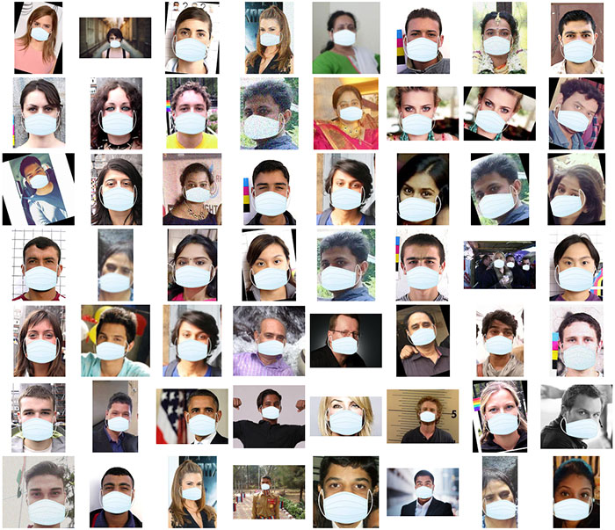



**Chandigarh Group of Colleges,**

**Jhanjeri, Mohali - 140307**

**Department of Computer Science & Engineering**

**Chapter 5: Implementation**

* **Import load_model from keras in tensorflow.**

In line 8 import load_model file from tensorflow.keras. This will decrease the time it takes to save the model and the amount of disk space occupied by the output SavedModel. If you enable this option, then you must provide all custom class definitions when loading the model. See the custom_objects argument in tf.keras.models.load_model. Set complie agument is True.

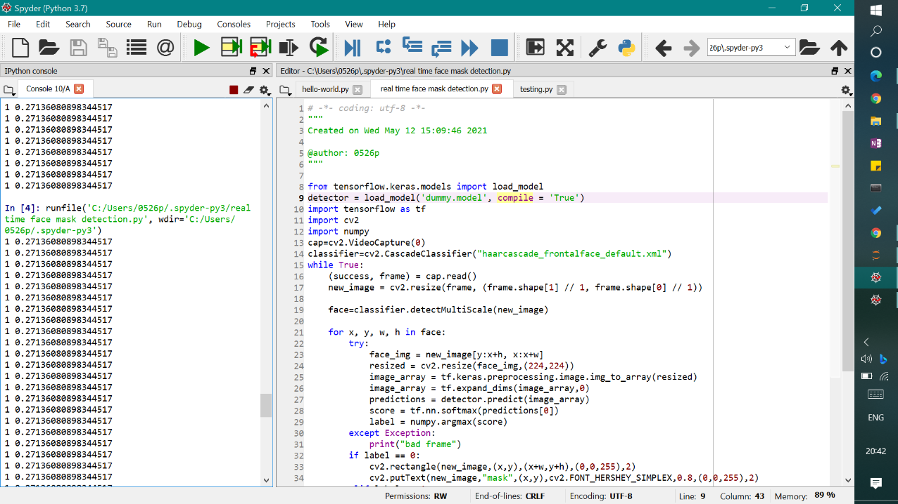

* **Implementing face mask detector training script with Keras and Tensorflow**

In line 10 import tensorflow as tf and keras libraries. Our set of tensorflow.keras imports allow for:

* Data augmentation
* Loading the MobilNetV2 classifier
* Building a new fully-connected (FC) head
* Pre-processing
* Loading image data



**Chandigarh Group of Colleges,**

**Jhanjeri, Mohali - 140307**

**Department of Computer Science & Engineering**

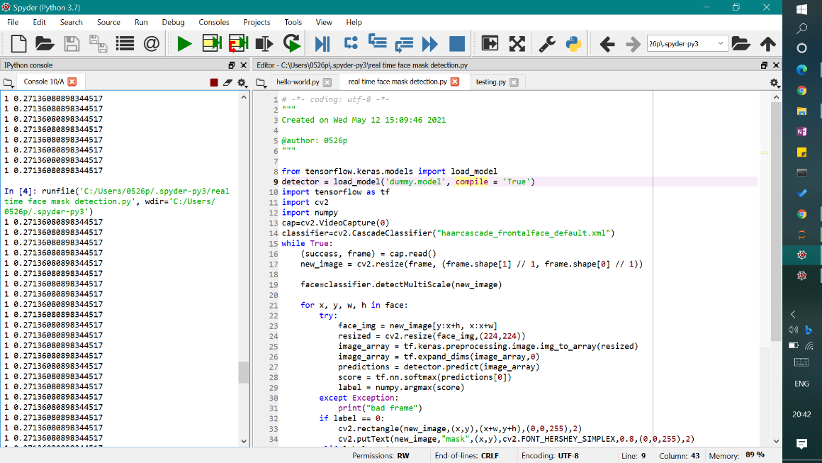

* **MobileNetV2**

To accomplish this task, you’ll be fine-tuning the [MobileNet V2 architecture](https://arxiv.org/abs/1801.04381), a highly efficient architecture that can be applied to embedded devices with limited computational capacity (ex., Raspberry Pi, Google Coral, NVIDIA Jetson Nano, etc.).

***Note:*** If your interest is embedded computer vision, then you need to know about how to work on it. [Raspberry Pi for Computer Vision book](https://www.pyimagesearch.com/raspberry-pi-for-computer-vision/) which covers working with computationally limited devices for computer vision and deep learning.

* **OpenCV2**

In line 11 import cv2 library which is designed to solve computer vision problems. OpenCV is an open-source library for the computer vision. It provides the facility to the machine to recognize the faces or objects.

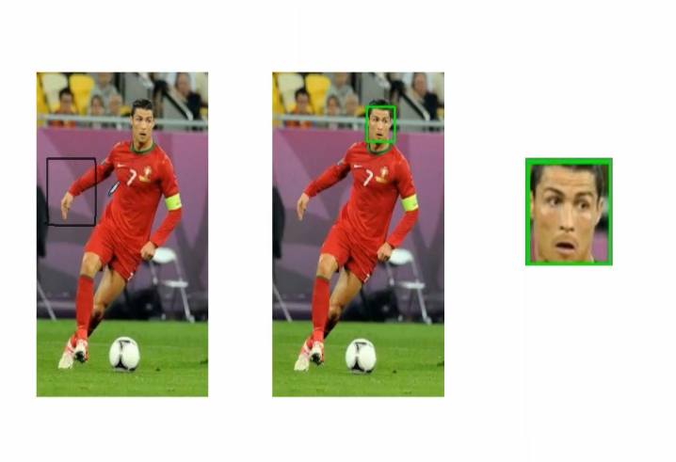



**Chandigarh Group of Colleges,**

**Jhanjeri, Mohali - 140307**

**Department of Computer Science & Engineering**

* **Numpy**

In line 12 import numpy library for converting the images which is the collections of pixels into set of arrays. It uses for identify the facial frames and select the extracting location.

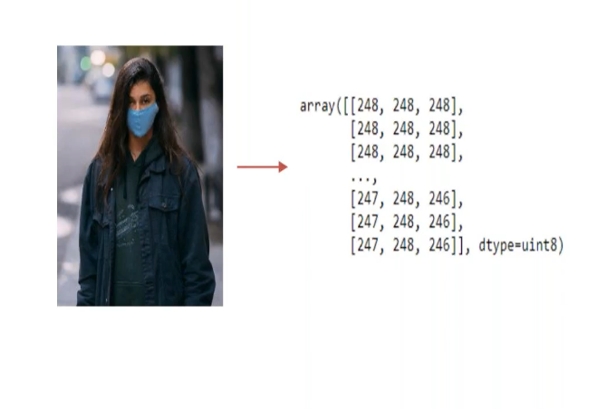

* In line 13 cv2.videoCapture(0) is taking the video frames using camera and stores each fames of image into the variables.





**Chandigarh Group of Colleges,**

**Jhanjeri, Mohali - 140307**

**Department of Computer Science & Engineering**

* **Cascade Classifier**

In line 14 cv2.CascadeClassifier("haarcascade_frontalface_default.xml") we provide the cascade classifier xml files using CV2 library. The cascade classifier splits the classification work into two stages: training and detection. The training stage does the work of gathering the samples which can be classified as positive and negative.

Haar Cascades can be used to detect any types of objects as long as you have the appropriate XML file for it. You can even create your own XML files from scratch to detect whatever type of object you want.

The term “cascade” means that the classifier thus produced consists of a set of simpler classifiers which are applied to the region of interest until the selected object is discarded or passed.

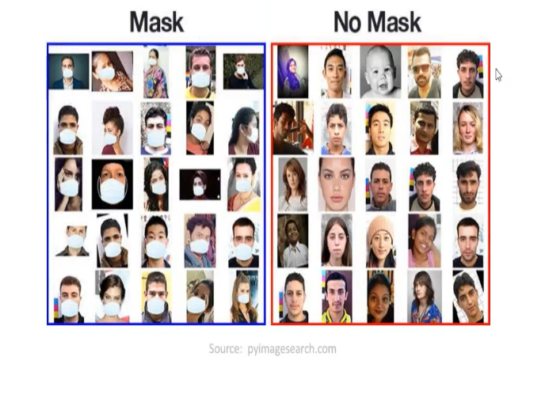

* Line 15 – 16 while is used for the imge read is true till loop is iterated. And in 16 cap.read() is read the image which is capture by the camera.



**Chandigarh Group of Colleges,**

**Jhanjeri, Mohali - 140307**

**Department of Computer Science & Engineering**

* In line 17 cv2.resize resize the capture image frame according to ours convince

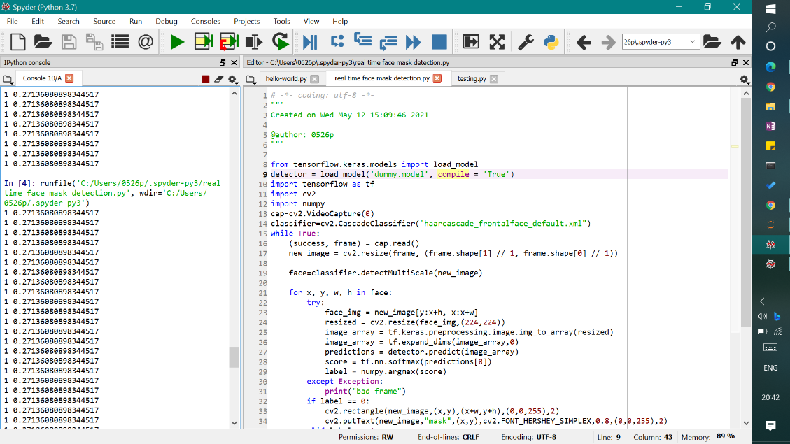

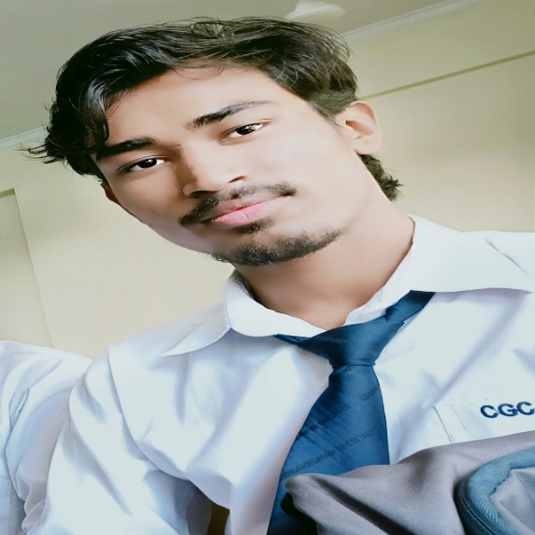

* In line 19 classifier.detectMultiScale(new_image) is  detects objects of different sizes in the input image. The detected objects are returned as a list of rectangles. Matrix of the type CV_8U containing an image where objects are detected.

The **face_classifier** which is an object loaded with **haarcascade_frontalface_default**.**xml,** we are using an inbuilt function with it called the **detectMultiScale.**This function will help us to find the features/locations of the new image. The way it does is, it will use all the features from the **face_classifier** object to detect the features of the new image.



**Chandigarh Group of Colleges,**

**Jhanjeri, Mohali - 140307**

**Department of Computer Science & Engineering**

* In line 21 – 31 we make a loop for iterating each of the frame and set to the coordinates of the images. Extract the region of interest using the coordinates, mark the rectangle. Then we extract the rectangular portion which is called region of interest and then resized it. Convert the image into the pixels of arrays. Then mark the facial frame which is covered by mask automatically predict the final image into the training datasets. If it is positive then mark the score and label it. If it failed to predict then it will mark with “bad frame”.

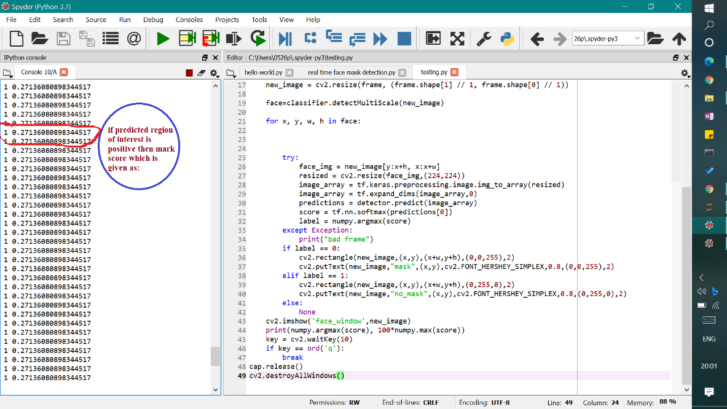

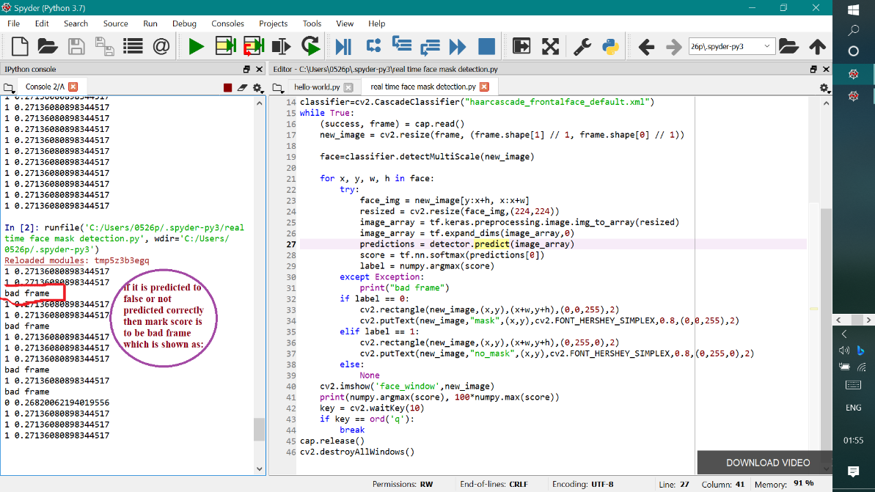



**Chandigarh Group of Colleges,**

**Jhanjeri, Mohali - 140307**

**Department of Computer Science & Engineering**

* In line 32 – 34, if the label data is 0 which means persons are wearing mask and mark the person face rectangle in green colour, colour code is enter as your choices and put the text over the rectangle is “mask”.

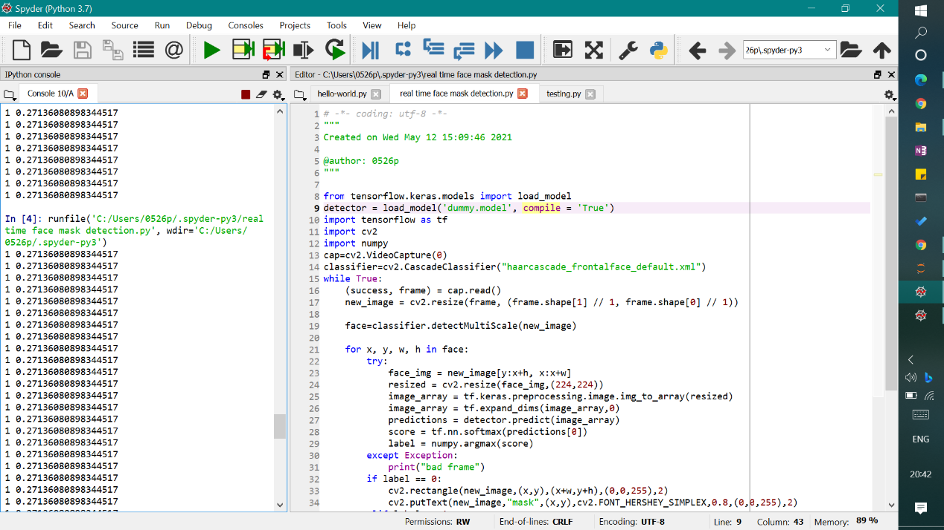

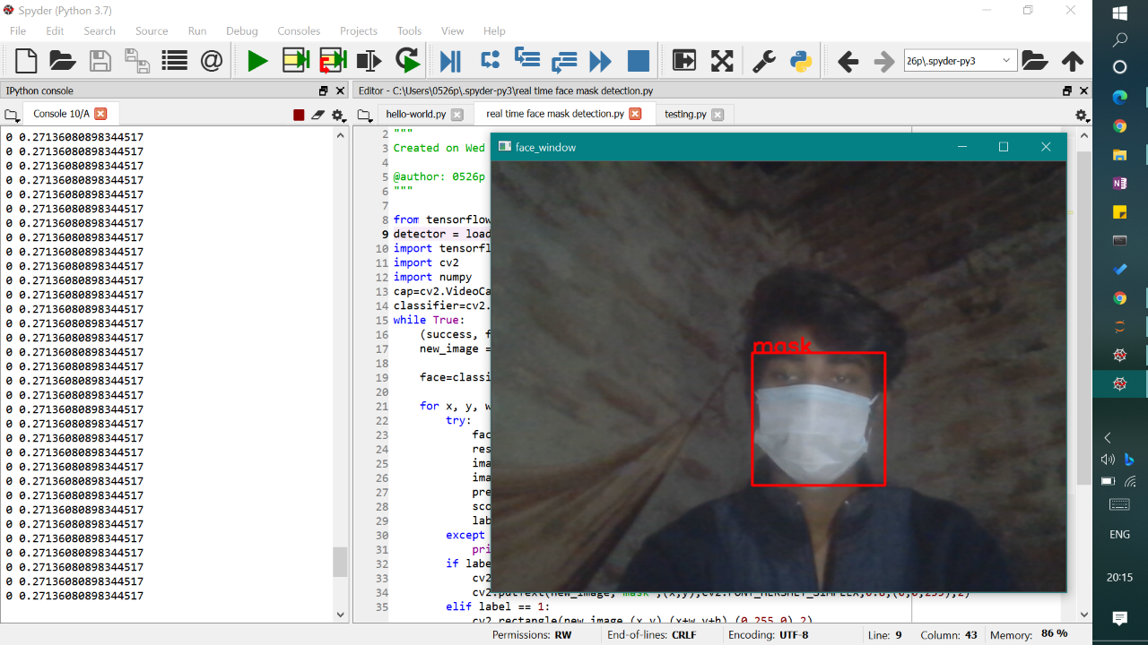



**Chandigarh Group of Colleges,**

**Jhanjeri, Mohali - 140307**

**Department of Computer Science & Engineering**

* In line 35 - 39, if the label data is 1 which means persons are not wearing mask and mark the person face rectangle in red colour, colour code is enter as your choices and put the text over the rectangle is “no mask”. Else it is None nothing is to be capture or streaming.

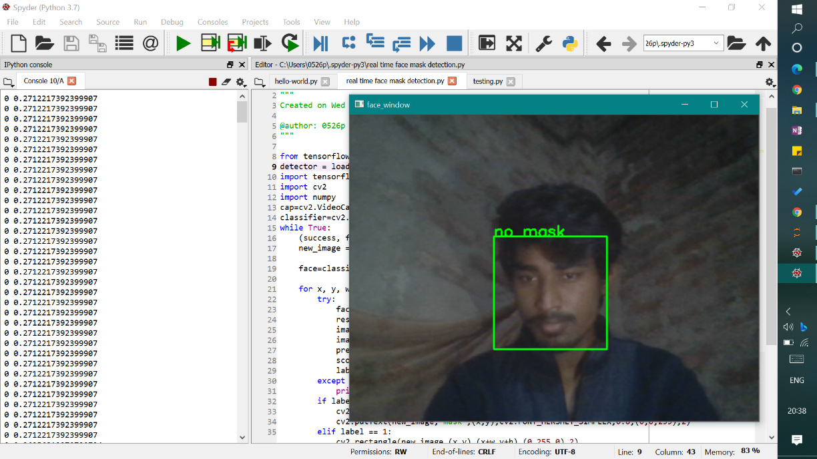

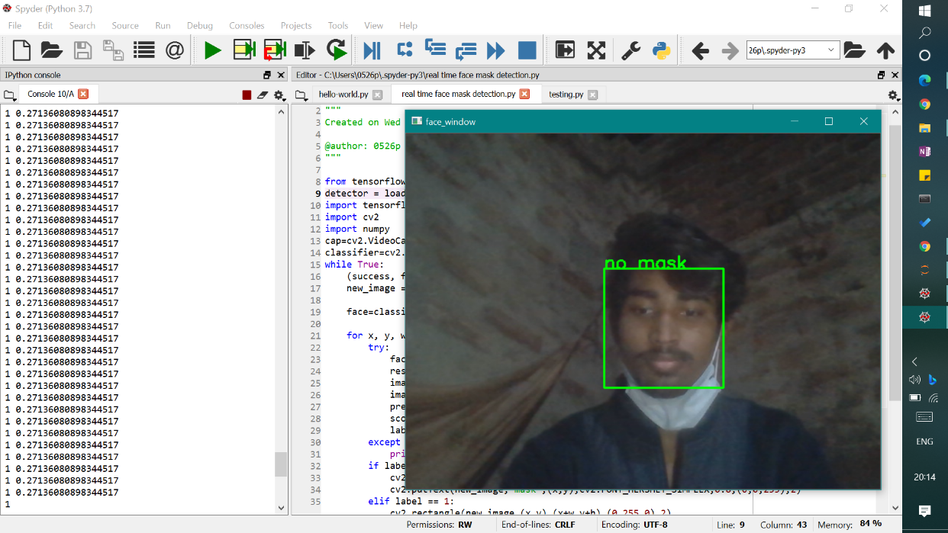

* In line 40 – 46, line 40 is when we run the code a window will be open which is capture your images and text display over the window is displayed “face_window”. Line 41 is print the score which we get from the predicted data. Line 42 is waitkey which is used for time lapse after the printing score for the next score which is predicted. Line 43 is close the window just press the q button on your keyboard. It breaks the loop, releases the data which is captured and destroys the all windows.
* 

**Chandigarh Group of Colleges,**

**Jhanjeri, Mohali - 140307**

**Department of Computer Science & Engineering**

**Chapter 6: References**

* **Download Anaconda –**

[https://www.anaconda.com/products/individual - Downloads](https://www.anaconda.com/products/individual%20-%20Downloads)

* **OpenCV documentation –**

<https://docs.opencv.org/master/d0/de3/tutorial_py_intro.html>

* **AIML face mask detection repository –**

<https://github.com/PrinceKumarKeshri/AIML-real-time-face-mask-detection>

* **Harcascades files –**

<https://github.com/PrinceKumarKeshri/AIML-real-time-face-mask-detection/blob/main/haarcascade_frontalface_default.xml>

* **Keras.model files –**

[dummy.model - Google Drive](https://drive.google.com/file/d/1SlY5b6T_0ijnrxS6MGLL8nOGw1eKQ1_J/view)

* **Download code from here –**

[https://github.com/PrinceKumarKeshri/AIML-real-time-face-mask-detection/blob/main/real time AIML face mask detection.ipynb](https://github.com/PrinceKumarKeshri/AIML-real-time-face-mask-detection/blob/main/real%20time%20AIML%20face%20mask%20detection.ipynb)